Step 1: Installed terraform

- A terraform template has been written and validated to find the errors if any.

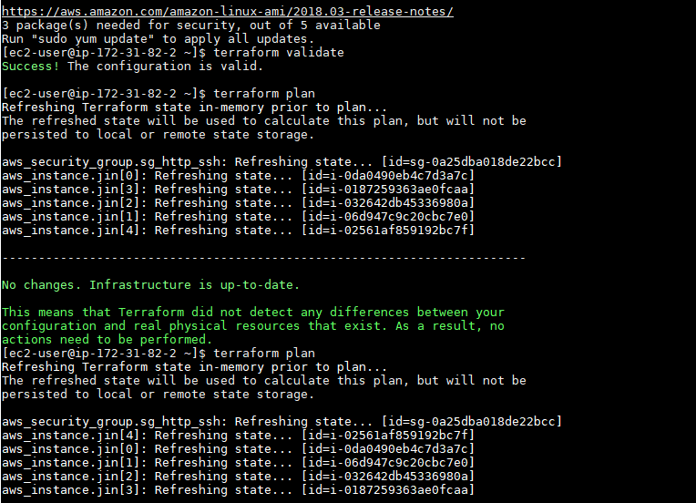

- Run the command terraform plan to get the what is the configuration with which the resource is going to be launched in AWS.

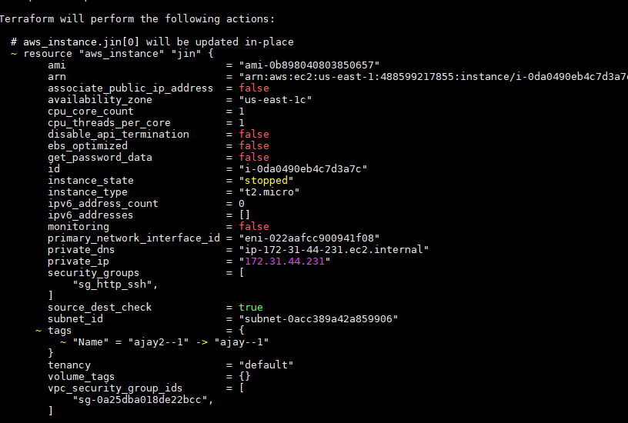

Run the command terraform apply to give your nod whether you want to launch the resource with the given config. or not?

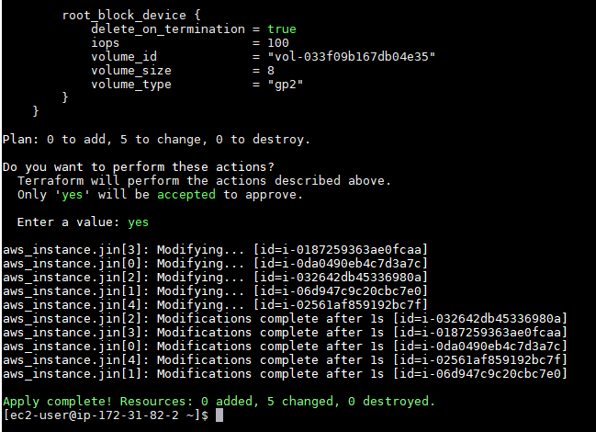

Security groups are configured in such a way that they allow only ssh and http inbound traffic.

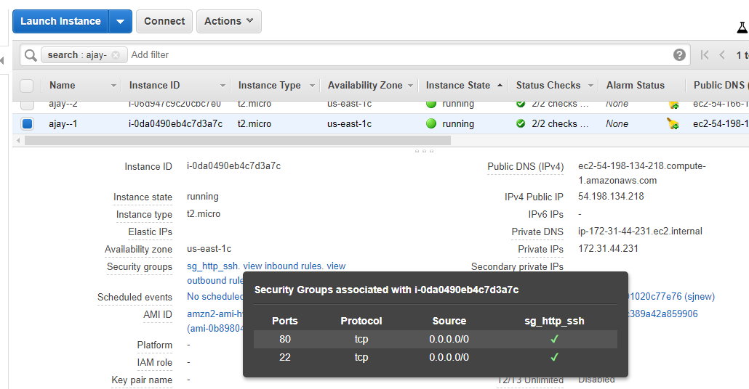

The outbound rule is set to all traffic.

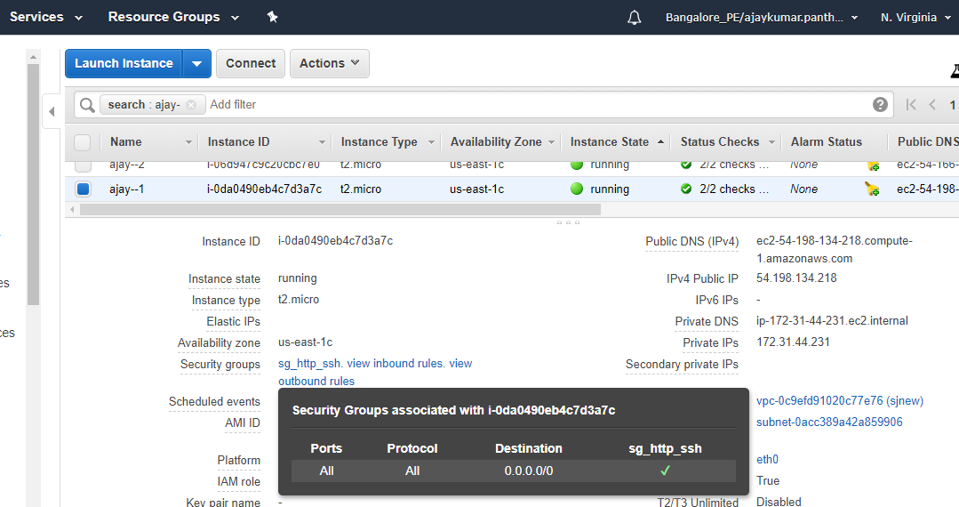

Finally, the ece2 instances are launched with the count that we give in variables.tf file.

They are also named in a way that name of the nth instance is <instance-name>--n.

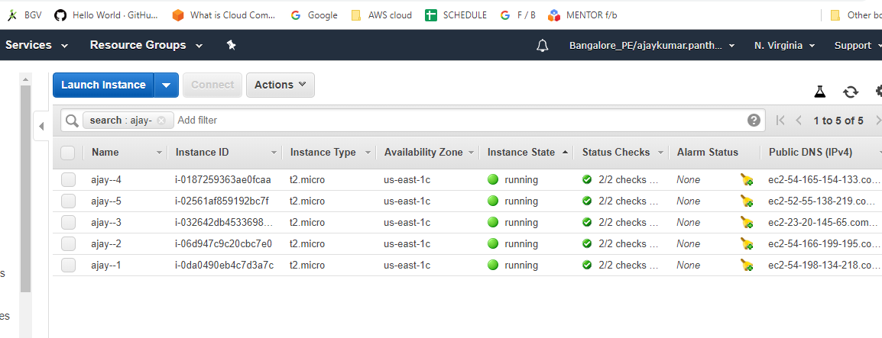

Variable.tf :

variable "instance_count"{}
variable "instance_name"{}
variable "my_region"{}
variable "my_ami"{}
variable "my_instance_type"{}

Terraform.tfvars:

instance_count=5
instance_name="ajay2-"
my_region="us-east-1"
my_ami="ami-0b898040803850657"
my_instance_type="t2.micro"
Terraform main.tf template:

provider "aws" {
region = "${var.my_region}"

}
resource "aws_instance" "jin" {
count = "${var.instance_count}"
ami = "${var.my_ami}"
instance_type="${var.my_instance_type}"
tags={Name = "${var.instance_name}-${count.index+1}"}
vpc_security_group_ids = ["${aws_security_group.sg_http_ssh.id}"]
}

resource "aws_security_group" "sg_http_ssh" {
name = "sg_http_ssh"
description = "Web Security Group"

ingress {
from_port = 80
to_port = 80
protocol = "tcp"
cidr_blocks = ["0.0.0.0/0"]
}
ingress {
from_port = 22
to_port = 22
protocol = "tcp"
cidr_blocks = ["0.0.0.0/0"]
}
egress {
from_port = 0
to_port = 0
protocol = "-1"
cidr_blocks = ["0.0.0.0/0"]
}
}

